Problem Set 6 – Questions in text.
Chapter 16: Problems 1 and 6

1. In the economy of Scottopia, policy makers want to lower the unemployment rate and raise real GDP by using monetary policy. Using the accompanying diagram, show why this policy will ultimately result in a higher aggregate price level but no change in real GDP.

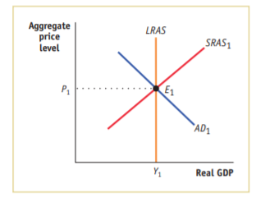

6. Concerned about the crowding-out effects of government borrowing on private investment spending, a candidate for president argues that the United States should just print money to cover the government’s budget deficit. What are the advantages and disadvantages of such a plan?

Chapter 17: Problem 1

1. Since the crash of its stock market in 1989, the Japanese economy has seen little economic growth and some deflation. The accompanying table from the Organization for Economic Cooperation and Development (OECD) shows some key macroeconomic data for Japan for 1991 (a “normal” year) and 1995–2003.
a. From the data, determine the type of policies Japan’s policy makers undertook at that time to promote growth.
b. We can safely consider a short-term interest rate that is less than 0.1% to effectively be a 0% interest rate. What is this situation called? What does it imply about the effectiveness of monetary policy? Of fiscal policy?
Year | Real GDP annual growth rate | Short-term interest rate | Government debt (percent of GDP) | Government budget deficit (percent of GDP)
1991 | 3.4% | 7.38% | 64.8% | −1.81%
1995 | 1.9 | 1.23 | 87.1 | 4.71
1996 | 3.4 | 0.59 | 93.9 | 5.07
1997 | 1.9 | 0.60 | 100.3 | 3.79
1998 | −1.1 | 0.72 | 112.2 | 5.51
1999 | 0.1 | 0.25 | 125.7 | 7.23
2000 | 2.8 | 0.25 | 134.1 | 7.48
2001 | 0.4 | 0.12 | 142.3 | 6.13
2002 | −0.3 | 0.06 | 149.3 | 7.88
2003 | 2.5 | 0.04 | 157.5 | 7.67

