Problem Set 5 – Questions in text.
Chapter 15: Problems 6 and 9

6. An economy is facing the inflationary gap shown in the accompanying diagram. To eliminate the gap, should the central bank use expansionary or contractionary monetary policy? How will the interest rate, investment spending, consumer spending, real GDP, and the aggregate price level change as monetary policy closes the inflationary gap?
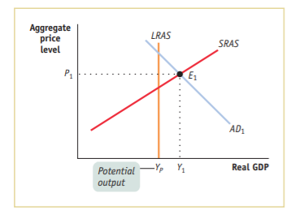

9. An economy is in long-run macroeconomic equilibrium with an unemployment rate of 5% when the government passes a law requiring the central bank to use monetary policy to lower the unemployment rate to 3% and keep it there. How could the central bank achieve this goal in the short run? What would happen in the long run? Illustrate with a diagram.

