Problem Set 4 – Questions in text.

Chapter 12

Problem

Suppose that in Wageland all workers sign annual wage contracts each year on January 1. No matter what happens to prices of final goods and services during the year, all workers earn the wage specified in their annual contract. This year, prices of final goods and services fall unexpectedly after the contracts are signed. Answer the following questions using a diagram and assume that the economy starts at potential output.

a. In the short run, how will the quantity of aggregate output supplied respond to the fall in prices?
b. What will happen when firms and workers renegotiate their wages?

1. A fall in the value of the dollar against other currencies makes U.S. final goods and services cheaper to foreigners even though the U.S. price level and subsequent inflation rate stays the same. As a result, foreigners demand more U.S. aggregate output. Your study partner says that this represents a movement down the aggregate demand curve because foreigners are demanding more in response to a lower price. You, however, insist that this represents a rightward shift of the aggregate demand curve. Who is right? Explain.
4. Suppose that the economy is currently at potential output. Also suppose that you are an economic policy maker and that a college economics student asks you to rank, if possible, your most preferred to least preferred type of shock: positive demand shock, negative demand shock, positive supply shock, negative supply shock. How would you rank them and why?
5. Explain whether the following government policies affect the aggregate demand curve or the short-run aggregate supply curve and how.
a. The government reduces the minimum nominal wage.
b. The government increases Temporary Assistance for Needy Families (TANF) payments, government transfers to families with dependent children.
c. To reduce the budget deficit, the government announces that households will pay much higher taxes beginning next year.
d. The government reduces military spending.

8. Using aggregate demand, short-run aggregate supply, and long-run aggregate supply curves, explain the process by which each of the following government policies will move the economy from one long-run macroeconomic equilibrium to another. Illustrate with diagrams. In each case, what are the short-run and long-run effects on the inflation rate and aggregate output?
a. There is a decrease in households’ wealth due to a decline in the stock market.
b. The government lowers taxes, leaving households with more disposable income, with no corresponding reduction in government purchases.
10. The economy is in short-run macroeconomic equilibrium at point E₁ in the accompanying diagram. Based on the diagram, answer the following questions.
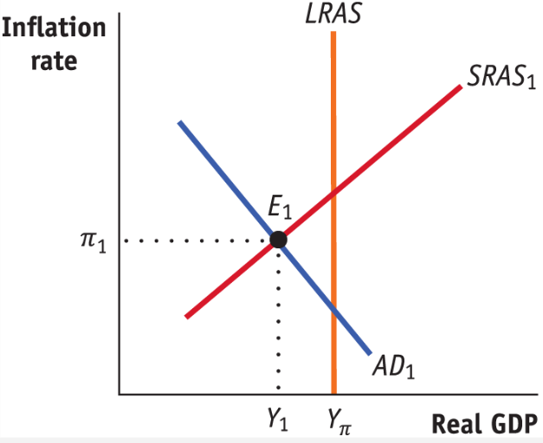

a. Is the economy facing an inflationary or a recessionary gap?
b. What policies can the government implement that might bring the economy back to long-run macroeconomic equilibrium? Illustrate with a diagram.
c. If the government did not intervene to close this gap, would the economy return to long-run macroeconomic equilibrium? Explain and illustrate with a diagram.
d. What are the advantages and disadvantages of the government implementing policies to close the gap?
Chapter 13
2. The accompanying diagram shows the current macroeconomic situation for the economy of Brittania; real GDP is Y₁, and the aggregate price level is P₁. You have been hired as an economic consultant to help the economy move to potential output, Y_{P}.
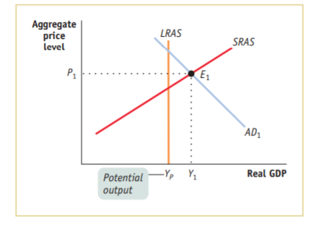
a. Is Brittania facing a recessionary or inflationary gap?
b. Which type of fiscal policy -- expansionary or contractionary -- would move the economy of Brittania to potential output, Y_{P}? What are some examples of such policies?
c. Illustrate the macroeconomic situation in Brittania with a diagram after the successful fiscal policy has been implemented.
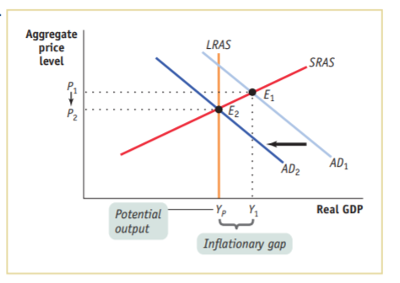
3. An economy is in long-run macroeconomic equilibrium when each of the following aggregate demand shocks occurs. What kind of gap -- inflationary or recessionary -- will the economy face after the shock, and what type of fiscal policies would help move the economy back to potential output? How would your recommended fiscal policy shift the aggregate demand curve?
a. A stock market boom increases the value of stocks held by households.
b. Firms come to believe that a recession in the near future is likely.
c. Anticipating the possibility of war, the government increases its purchases of military equipment.
d. The quantity of money in the economy declines and interest rates increase.
6. In each of the following cases, either a recessionary or inflationary gap exists. Assume that the aggregate supply curve is horizontal, so that the change in real GDP arising from a shift of the aggregate demand curve equals the size of the shift of the curve. Calculate both the change in government purchases of goods and services and the change in government transfers necessary to close the gap.
a. Real GDP equals $100 billion, potential output equals $160 billion, and the MPC is 0.75.
b. Real GDP equals $250 billion, potential output equals $200 billion, and the MPC is 0.5.
c. Real GDP equals $180 billion, potential output equals $100 billion, and the MPC is 0.8.

