Study Guide 2 – ECON 1002

- What do we mean by the Savings-Investment Identity?
- What is the difference between physical, financial and human capital?
- What do we mean by the loanable funds market?
- What is the relationship between the rate of interest and the demand for loanable funds?
- What is the relationship between the rate of interest and the supply of loanable funds?
- Using a diagram such as that below, label the axes and show equilibrium in the loanable funds market.
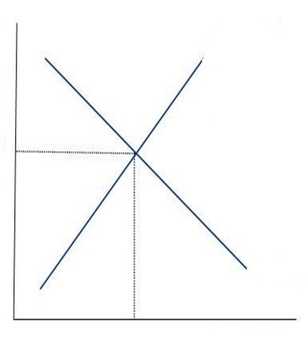

- Now assume the loanable funds market is in equilibrium. Show the effects of changes such as selling bonds by the government, an increase in expected inflation etc. on the interest rate and the amount of loanable funds.
- What is the difference between nominal and real interest rates?
- What do we mean by crowding-out? Explain
- What do we mean by the marginal propensity to consume? What do we mean by the marginal propensity to save?
- What factors result in a shift of the consumption function?
- What factors determine the shape of the investment demand function?
- What do we mean by planned and unplanned investment?
- Be able to solve mathematically for equilibrium income as shown in problems in the problem sets.
- What do we mean by the simple multiplier? Be sure to understand the formula and how it is used.
- Suppose the MPC is 0.8 and government increases expenditures by $1,000,000, what is the total impact on income?

- In the simple Keynesian model, we assume that investment is fixed over the period and prices do not change. Looking at the diagram below, what happens to GDP if unplanned investment is negative? Positive?

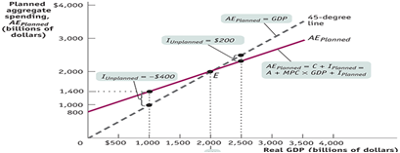

- Why does the aggregate demand curve slope downward?
- Why does the aggregate supply curve slope upward?
- What is the difference between the short-run and long-run aggregate supply curve? Explain the reasoning behind the shapes.
- Be able to explain all the factors that shift both the AD and AS curves.
- Construct a number of different scenarios in which the AD and/or AS functions will shift. Show the effects on the price level and real output.
- Using the AD-AS model explain the effects of the following factors below. Be sure to describe the changes that take place in the short run and long run. Start at full employment equilibrium and then show diagrammatically and explain verbally the short and long run effects (assume not government intervention).
  - Decrease in consumers’ expectations (people are getting worried about the future of the economy).
  - Increase in the price of oil.
  - Increase or decrease in investment
  - Increase of decrease in government spending or taxes

- What do we mean by a supply-shock? Give examples.
- What do we mean by cost-push inflation? What do we mean by demand-pull inflation? Show the effects of each using the AD-AS model.
- What do we mean by stagflation?
- Using the AS-AD model, show the effects of fiscal policy responses to inflation and recession. What are the costs and benefits of each policy?
- Using the simple multiplier, what is the effect of an increase in government spending of 100 million if the MPC is equal to 0.75?
- Using the simple multiplier, what is the effect of a decrease in lump sum taxes of 50 million if the MPC = 0.9?
- What do we mean by the balanced budget multiplier? Does an equal increase in G and T (lump-sum) taxes have a neutral effect or positive on GDP or Y? Explain.
- Using the simple multiplier, what is the effect of an increase in government spending of 100 million that is paid for tax increase of 100 million if the MPC is equal to 0.9?
- What do we mean by a discretionary fiscal policy?
- What is an example of an automatic stabilizer? How do they work?
- What do we mean by transfer payments? How do they work?
- Be able to understand how the Government carries out fiscal policy.
- What are the functions of money?
- Be sure to understand what components make up M1, M2?
- What do we mean by the monetary base (what are the two components)?
- How do banks create money? What is meant by the money multiplier?
- Sample question: A bank has $400,000 in checkable deposits and $50,000 in currency. The reserve requirement is 10 percent. The bank's required reserves are _________, and its excess reserves are ________.
- Given the information above, what is the maximum the money supply will be able to expand?

