Chapter 4 - Homework Questions
- Simple Interest versus Compound Interest. First City Bank pays 6 percent simple interest on its savings account balances, whereas Second City Bank pays 6 percent interest compounded annually. If you made a deposit of $8,100 in each bank, how much more money would you earn from your Second City Bank account at the end of 10 years?
- Calculating Future Values. For each of the following, compute the future value:
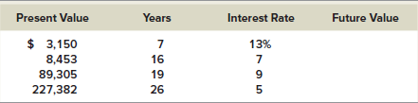

- Calculating Present Values. For each of the following, compute the present value:
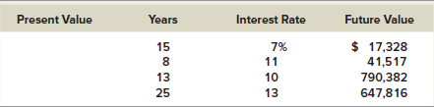
- Calculating Interest Rates. Solve for the unknown interest rate in each of the following:
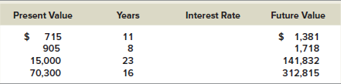
- Calculating Rates of Return. Assume the total cost of a college education will be $295,000 when your child enters college in 18 years. You presently have $53,000 to invest. What annual rate of interest must you earn on your investment to cover the cost of your child's college education?
- Calculating Present Values. You need $85,000 in 10 years. If you can earn .65 percent per month, how much will you have to deposit today?

