Some Practice Problems

- You are given the following information on tax rates.
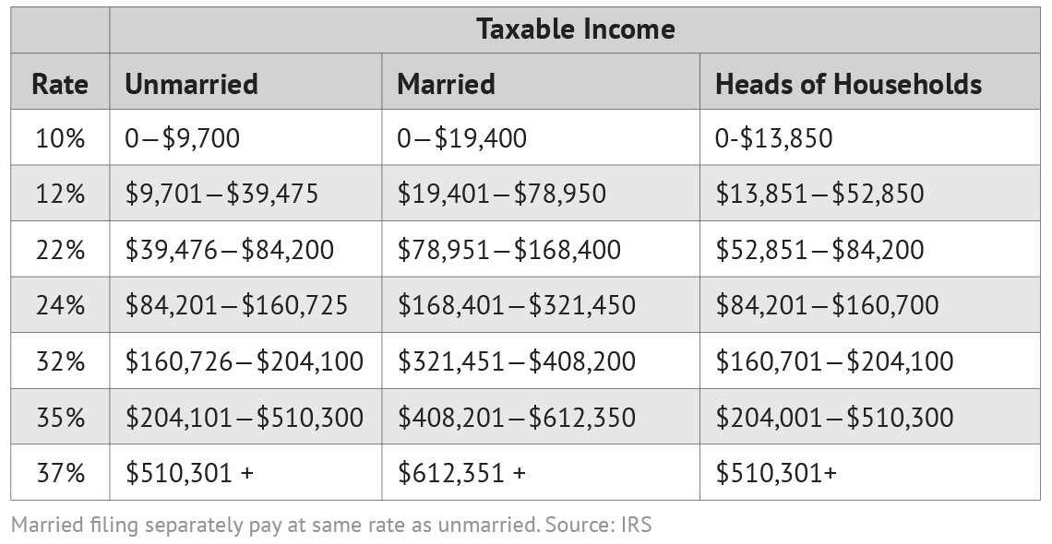

- What is the total tax paid for an unmarried individual earning $60,000 per year?

- What is the total tax paid for a married individual earning $60,000 per year?
- What are their average tax rates?

- In recent years, the InAPickle Co. has seen its Days’ Sales in Accounts Receivable greatly increase. What factors may have contributed to this development? Is this good or bad? Explain.

- The recent price of a share of InAPickle Co. was $23.35. The number of shares outstanding is 2,200,000. Net Income was found to be $3,333,000. Given this information, calculate the Price-Earnings ratio for this company.

- A higher profit margin is always desirable since it means the company generates more profits from its sales. However, profit margins can vary by industry. Explain why this is the case.

- Happy Harry won a prize for best looking baby girl and won 100,000QR. He wants to finance the future study of his newly born daughter and invests this money in a fund with a maturity of 18 years offering a promising yearly return of 6%. What is the amount available on the 18th birthday of his daughter?

- Mr. Bean will retire in 20 years. This year he wants to fund an amount of US$215,000 to become available in 20 years. How much does he have to deposit into a pension plan earning 3.5% annually?

- Say that you are buying a refrigerator, and make a $400 payment one year from now and another $400 payment two years from now. What is the present value of your total payment given an interest rate of 3%?

- Suppose you are a producer of mangoes. You currently produce 136,000 kg per year. How long will it take for your output to grow to 268,000 kg if production is growing at an annual rate of 8%?

- Snapchat wants to double the number of its subscribers. If the current growth rate of 9% per year is expected to continue, about how long will it take Snapchat to reach its goal?

- At what annual interest rate must $137,000 be invested so that it will grow to be $475,000 in 14 years?

- Bank A pays 3.5% simple interest on your deposit of $1000 that you will keep in the bank for 5 years. Bank B pays 3.2779% interest compounded annually. In which bank will you deposit your money?

